Project 12

1- what is UID?

A **user ID** (**UID**) is a unique positive integer assigned by a Unix-like operating system to each user. Each user is identified to the system by its **UID**, and user names are generally used only as an interface for humans.

2- what is GID ?

- Group id: n a Unix system, a **GID** (group ID) is a name that associates a system user with other users sharing something in common (perhaps a work project or a department name.

To check to uid of group: etc/group

3- what command do you type to check the UID of an account?

# id

# id username

4- what command do you type to check what group an account belongs to?

# logins - g <group>

# id -g

# groups username

# cat /etc/group

5- what command would you type to check a user's account component?

# cat /etc/passwd

6- the -g of useradd command is used to add a user to a primary group. what is the option used to add a user to a subgroup or suplementary group?

# useradd -G

#id -a (user)to verify

7- how do you get help on a Linux server?

# man <request>

8- from a server prompt , how can you connect remotely to another server if you don't have access to putty.

# scp command

#wiscp for windows

9- create a file on your server called yourname, then use scp to copy it to my server

( 96.245.84.63 , username= class3 password= school1 ) put it in /tmp

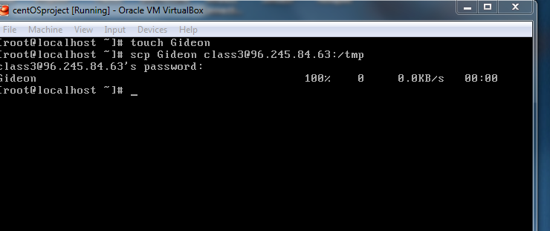

10- download the redhat iso image from site ftp://96.245.84.63/software (login: class3 , password= school1 the iso image is rwd-rhel64i386.iso)

11- Watch the video on redhat installation in your video folder and then install redhat in your virtualbox.